CSA0301-Data Structures
Activity1

1. Student Marks Record: Write an C program to collect the marks of 5 students in 4subjects using a 2-dimensional array. Display the marks, calculate the total and average marks of each student, and identify the topper.

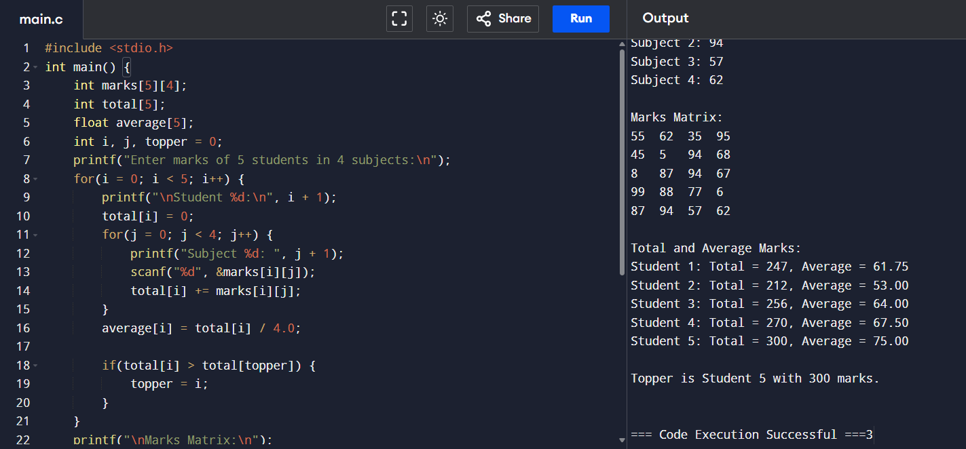n
2. Employee Salary Record: Write an C program to collect the monthly salaries of 6 employees for 3 months using a 2-dimensional array. Display the salary matrix and calculate the total salary paid to each employee.
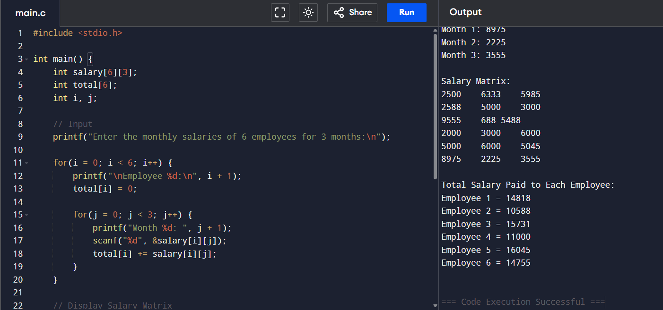

3. Hospital Patient Billing: Write an C program to collect the treatment charges of 5 patients under 4 billing categories (Consultation, Lab Test, Medicine, Room Rent) using a 2-dimensional array. Calculate the total bill for each patient.
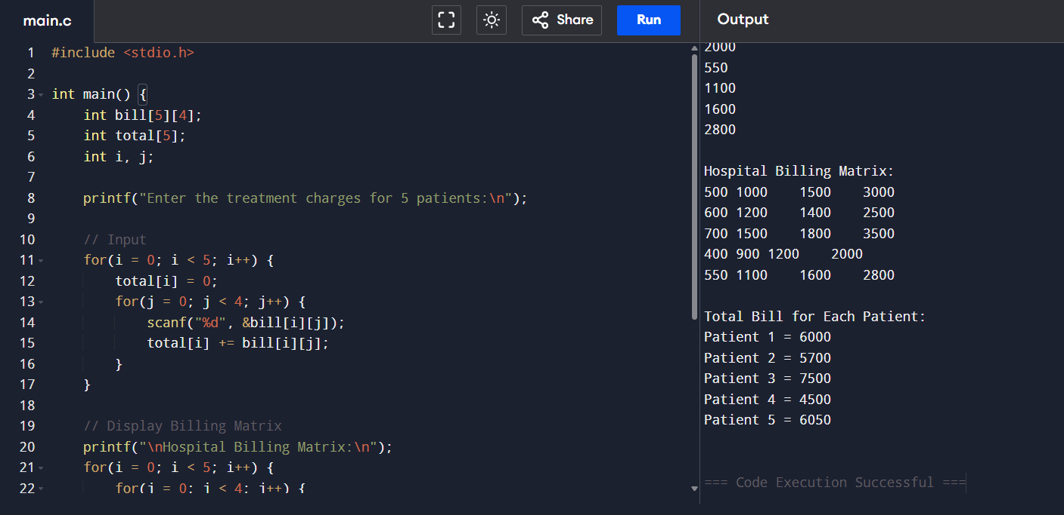

4. Cricket Scoreboard: Write an C program to collect the runs scored by 6 players in 5 matches using a 2-dimensional array. Display the scorecard, calculate each player&#39;s total runs, and determine the highest scorer.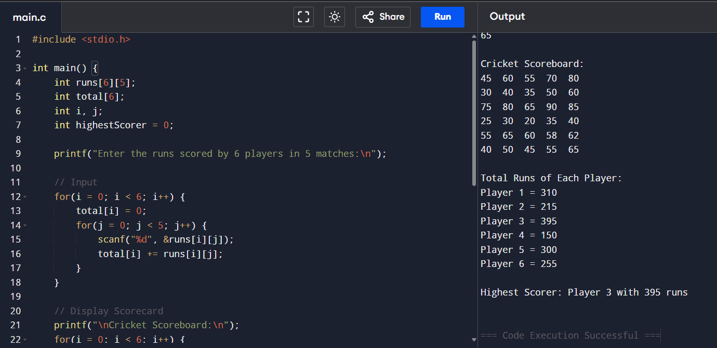
5. Library Book Issue Record: Write an R program to collect the number of books issued by 5 departments during 4 weeks using a 2-dimensional array. Display the data and calculate the total books issued by each department.
